SACRAMENTO COUNTY AMENDMENT TO THE 2000 UNIFORM FIRE CODE

APPENDIX VII

EMERGENCY ACCESS GATES AND BARRIERS

(See UFC Section 902.2.4.2)

SECTION 1 - SCOPE
Where a new gate or barrier is installed on a fire access roadway, it shall be authorized by the Chief and meet the minimum requirements of Appendix VII. Private driveways on lightly traveled streets as determined by the Sacramento County, Department of Transportation or the appropriate public works agency having jurisdiction, serving one single-family residence may be exempt from the scope of this document. Approval of automated gates or barriers is subject to the owner accepting responsibility for any future programming requirements by the authority having jurisdiction.

SECTION 2 - DEFINITIONS
For the purposes of APPENDIX VII, certain terms are defined as follows:
100% CONCURRANCE OF PROPERTY OWNERS will consist of a signed, notarized copy of Appendix VII - Form A, Emergency Access Gates and Barriers, by each property owner served by the gate;
AUTHORITY HAVING JURISDICTION is any agency having statutory authority to enforce federal, state, county, city, or district laws, ordinances or standards;
GATES AND BARRIERS – shall mean a gate, crossbar, door or other obstructive device which is utilized for the purpose of restricting, controlling or obstructing entry or exit by motor vehicles or pedestrians to or from a private roadway and which is not manned on a twenty-four hour, seven day per week basis by a person capable of providing immediate access to a police or fire safety vehicle or person;

PRIVATE STREET OR ROADWAY – shall mean any roadway (not dedicated as public right-of-way) that is owned and maintained by abutting property owners, or association of property owners that is utilized for the purpose of providing vehicular or pedestrian access to a subdivision, apartment complex, condominiums or other residential development or wild land, excluding off-street parking areas, driveways, and driveways to off-street parking areas.

PRIVATE DRIVEWAY -- A private way for vehicular travel that provides access from an off-street parking area to a public or private drive.

ULTIMATE EDGE OF RIGHT-0F-WAY is the line furthest from the centerline of the street that has been approved by the County and recorded on the parcel map for existing or future street improvements.

SECTION 3 - PERMIT
A permit issued by the fire authority having jurisdiction to design and install any secured access gate system shall be obtained and approved in writing prior to installation. The gate permit may be revoked and the gate locked in the open position for any cause determined by the authority having jurisdiction to be in the interest of public safety.
SECTION 4 - REQUIRED SUBMITTAL LOCATIONS
4.1 Unincorporated areas of the county. Approvals are required from the five (5) agencies having jurisdiction over the installation of gates & barriers. A total of eight (8) sets of information will be required to be submitted at the 1st office. All copies returned to the applicant shall have the approval stamp and signature of the plan review officer prior to taking them to the next office. Following the agencies, copies will be provided as noted. Each office will retain one copy for their records. Submittals for applications to install gates or barriers shall be in the following order:
4.1.1 1st Office: Department of Transportation, Sacramento County, 906 G Street, Sacramento, CA 95814; (916) 874-5374.
4.1.2 2nd Office: Planning Department, Sacramento County, 827 7th Street, Room 101, Sacramento, CA 95814; (916) 874-6141
4.1.3 3rd Office: Sheriff’s Department, Sacramento County, Community Development Assistant Planner, Community Oriented Policing Strategies Division, 4221 North Freeway Blvd, Suite A-1, Sacramento, CA 95834; (916) 874-5986
4.1.4 4th Office: The Fire Prevention Bureau of the fire district having jurisdiction:
- Courtland Fire District; (916) 775-1210
- Delta Fire District; (707) 374-2233
- Galt Fire District, Fire Prevention, 208 A St., Galt, CA 95632; (209) 745-1001
- Herald Fire District; (209) 748-2322
- Isleton Fire Protection District, 100 Second Street, Isleton, CA 95641; (916) 777-7776
- Sacramento Metro Fire District, 3012 Gold Canal Drive, Rancho Cordova, CA 95670; (916) 942-3300.
- Walnut Grove Fire District; (916) 776-1090
- Wilton Fire District; (916) 687-6920
4.1.5 5th Office: The Sacramento County Building Dept., 4101 Branch Center Road, Sacramento, CA 95827; (916) 875-5400 – A Miscellaneous Electrical Permit is required for all electrical gate installations.

4.1.6 Provide copies to:
a. The property owner or Association (1 Copy)
b. The electrical contractor (1 Copy)
c. The gate contractor (1 Copy)
4.2 Incorporated areas of the county (Cities) – Applications for gates within incorporated areas shall be submitted to the city locations listed below or as directed by their information services. Do not begin the process at the County Transportation Office.
4.2.1 Citrus Heights. Plans for the City of Citrus Heights shall be submitted to the Sacramento Metropolitan Fire District, 3012 Gold Canal Drive, Rancho Cordova, CA 95670 (916) 942-3300.
4.2.2 Elk Grove. Plans for the City of Elk Grove shall be submitted to Elk Grove Fire Dept., 8820 Elk Grove Blvd., No. 2, Elk Grove, CA 95624
4.2.3 Folsom. Plans for the City of Folsom shall be submitted to the City of Folsom, Planning, Inspections and Permitting Dept., 50 Natoma St., Folsom, CA 95630; (916) 355-7222
4.2.4 Sacramento. Plans for the City of Sacramento shall be submitted to the City of Sacramento, Fire Prevention Office, 1231 I Street, Suite 401, Sacramento, CA 95814; (916) 264-5260.
Helpful hint – the process can be quicker if the applicant will make an appointment with the plan review officer to look at the plan at the time of submittal. It does not mean that the plan will be approved “over the counter”, but any obvious missing items could be caught at that time.

SECTION 5 - SUBMITTALS
A minimum of eight (8) complete sets of information shall be submitted to the Department of Transportation and shall include the following:
5.1 Approved verification of 100% Concurrence of Property Owners. The applicant shall provide, with the gate application, verification that all existing property owners served by gate installation agree to its installation and operation. Each property owner shall provide a signed copy of the agreement noted as Appendix VII, Form A – Emergency Access Gates and Barriers (at the end of this document). In addition, the applicant shall provide a copy of the amended “Road Maintenance Agreement” identifying the addition of the gates and operating systems. Where there is only one property owner, Appendix VII, Form A – Emergency Access Gates and Barriers must be signed by the property owner and the gate contractor.
5.2 A site plan of the property and a site detail of each gate location, drawn to scale (1”=10’, 1”=20’, or 1”=40’), indicating or showing:
a. Approval stamps from the Sacramento County Department of Transportation, the Sacramento County Planning Department and the Sacramento County Sheriff’s Office;
b. C-10 electrical contractors stamp on the plans for the electrical installation;
c. C-13 fence contractors stamp on the plans for the installation of the gate;
d. Plans for gates over 6 feet in height shall bear the stamp of a structural engineer and must be accompanied by a Sacramento County Building Permit Number.
e. Contractors company name, address, phone number and contact person.
f. Exact locations of the entry to the property (i.e. On the east side of Fulton Ave, 620 feet north of the center of Marconi Ave. in the Sacramento area);
g. Assessors Parcel Number (located on the property owners tax bill);
h. Property Lines;
i. Fire Hydrants, fire department connections;
j. Location of the “ultimate back of right-of-way”;
k. Location of the existing edge of pavement or gutter line;
l. Building footprints, including doors, walkways and fire control room doors; parking spaces and landscape affected;
m. Proposed fence, pedestrian gates, vehicle gates;
n. Existing vehicular access;
o. Proposed location of Knox® key switch / Knox® box(s);
p. Physical address and;
5.3 Product specifications shall be provided that include:
a. Method of operation;
b. UL listing numbers of equipment used and;
c. Manufacturers specification sheets for electrical gate controller.
5.4 Maintenance. Emergency access gates and barriers shall be maintained and may include:
- Batteries required for operation of the system during power failure;
b. Lubrication of moving parts and hinges per manufacturers specifications and;
c. Any subsequent attention required to maintain the original list of frequencies for emergency operation of the gate in the controller.
5.5 Plan review and inspection fees will be collected per each agency’s approved fee schedule.

SECTION 6 - MINIMUM REQUIREMENTS
6.1 Vehicle Gates – See Attached Layouts
6.1.1 Access
a. All gates shall be UL 325 compliant.
b. Gates shall not be installed within a required turning radius of a fire access roadway.
c. Access for single direction traffic shall be unobstructed 16 feet wide and 13’, 6” high.
d. Access for bi-directional traffic shall be unobstructed 20’ wide and 13’, 6” inches high.
e. Swinging gates for single direction traffic shall swing in the direction of vehicle travel.
f. Swinging gates for bi-directional traffic shall swing into the property being entered.
g. Locations of gates shall be as approved by the Sacramento County, Department of Transportation, on a case-by-case basis. To find out where the ultimate edge of right-of-way is, contact Sacramento County, Land Division & Site Improvement Review, 827 7th Street, Room 102-105, Sacramento, CA 95814, (916) 874-6591
h. All gates shall be accessible from the driving lane nearest the edge of the street by turning radii of at least 38’ inside and 58’ outside.
i. After passing through a gate, the nearest curb of any cross street shall be no less than 40 feet.
j. Private driveways serving one single-family residence on moderate and heavily traveled streets shall:
1. Meet the setback requirements of this appendix. If existing conditions prevent gate installation with 40’ of clearance to the face of the gate, a letter documenting an acceptable alternative that would facilitate emergency ingress without endangering emergency response personnel and apparatus will be required for review and approval by the Chief;
2. Meet the operational requirements of electrically operated gates.
6.1.2 Operation of Gates
a. All gates shall be electrically operated for entry and exit by an approved fire department method:
1. Key override switch (Knox®) and
2. Radio operated controller (Click2Enter© or other approved equipment).
Exception: Radio controlled exit may be waived by installation of a “free exit” loop.
b. Gates requiring radio-controlled exit shall be provided with an approved 2 inch by 2 inch, blue, reflective marker visible to the exiting traffic. It shall be located in the center of the exit gate.
c. Wiring for electrical gates shall be provided by AC current, underground installation. A miscellaneous electrical permit is required by the Sacramento County Building Department.
d. Electrically operated gates shall fail to the open position when the power is off. They shall remain open until power is restored.
e. Knox® Company authorization forms are required for orders of key switches, boxes and padlocks. The forms may be obtained by calling the fire authority having jurisdiction or the Sheriff’s Office.
6.1.2.1 Manual gates or barriers may be approved on a case-by-case basis for nighttime security of business property or access to wild lands.
a. They shall be constructed in a manner that reflects good construction practices acceptable to the fire authority having jurisdiction.
b. They shall be accessible by means of an approved fire department padlock (Knox®) or by the installation of an approved key box (Knox®).
c. Approved manual gates or barriers across emergency access roadways shall be provided with an 18-gauge metal sign in the center of and on both sides of the gate that shall read, “FIRE LANE- NO PARKING”. Letters shall be red on a white background and be a minimum of 3” high with a ½” stroke.
d. Gates to close off a fire lane behind strip malls/stores in order to minimize dumping and vandalism shall be approved with (Knox®) padlock access.
6.1.3 Prohibitions
a. No gate shall be installed where access requires the use of a proximity reader or card, unless a “turn-out” is provided for its use.
b. Direction-limiting devices, such as fixed tire spikes, are prohibited.
c. The total number of vehicle access control devices or systems, through which emergency vehicles must pass to reach any address shall not exceed one.
d. No commercial property owner shall install fences and gates where more than one gate must be opened in order to reach within 150 feet of the rear portion of any building.
6.2 Pedestrian Gates
All vehicle gates obstructing pedestrian access to a public way (street) shall have an approved pedestrian gate installed within 10 feet of the vehicle gate.
a. Gates shall be handicap accessible and comply with exit door requirements of the Uniform Building Code.
b. An approved key box (Knox®) shall be installed at least 48” above grade on the outside of the gate. It shall be provided with a key to open the pedestrian gate.
c. No pedestrian gate shall be located in the median between two vehicle gates.
Exception: Private driveways serving one single-family residence are exempt from this requirement.

SECTION 7 - INSTALLATION APPROVAL
The fire authority having jurisdiction shall inspect all gates for proper installation and operation prior to activation or use.

SECTION 8 - ADDITIONAL REQUIREMENTS
Because of the delays caused by vehicle access control devices or systems, additional fire protection requirements may be applied based on other access limitations, such as narrow or winding streets, or dead-end streets without an approved turnaround available for fire apparatus.
Other than the obstruction and the reduced width controlled within this standard, no other requirement of the fire authority having jurisdiction shall be adversely affected by the placement of any vehicle access control device or system in any required fire apparatus access road.
Fire department approval does not waive any requirement by other authorities having jurisdiction.

SACRAMENTO COUNTY AMENDMENT TO THE 2000 UNIFORM FIRE CODE

APPENDIX VII

FORM A - EMERGENCY ACCESS GATES AND BARRIERS

UNDERSTANDING AND AGREEMENT

I/we understand and agree with the conditions of Appendix VII, Form A – Emergency Access Gates and Barriers to install and maintain controlled access to the private street/roadway shown on the attached plans including the parcel number listed below. I/we understand that FAILURE TO COMPLY with any condition herein shall constitute a violation of U.F.C. Section 902.2.4.2 and is grounds for immediate revocation of this permit to have a security gate or barrier. I also understand that once the gate system is approved and activated, it shall not be tampered with, without the written approval of the fire department and sheriff’s office except by authorized maintenance personnel.

I HAVE READ, UNDERSTAND AND AGREE TO COMPLY WITH ALL CONDITIONS HEREIN.

GATE CONTRACTOR: _________________________________________ DATE: ______________

PROPERTY OWNER: _________________________________________ DATE: ______________

Parcel Number: _______________________________

FINAL INSPECTION APPROVAL BY _______________________________DATE: ______________

AGENCY__________________________________________________
(Final approval may be verified by a signed fire department inspection card.)

References:

- Click2Enter® Distributors:
- Encon Electronics, 28310 Industrial Blvd., Suite 1, Hayward, CA 94545, (800) 782-5598
B. First Solutions, Inc., 4220A Roseville Road, North Highlands, CA 95660, (916) 338-5122
(916) 338-4567 FAX dave@alarmsun.com

- Knox®
Information and order forms are available at the Fire Prevention Office or at the Sacramento County Sheriff’s Office as noted in the above document Items 4.1.3 and 4.1.4.

Entry Gate Layout For New Developments

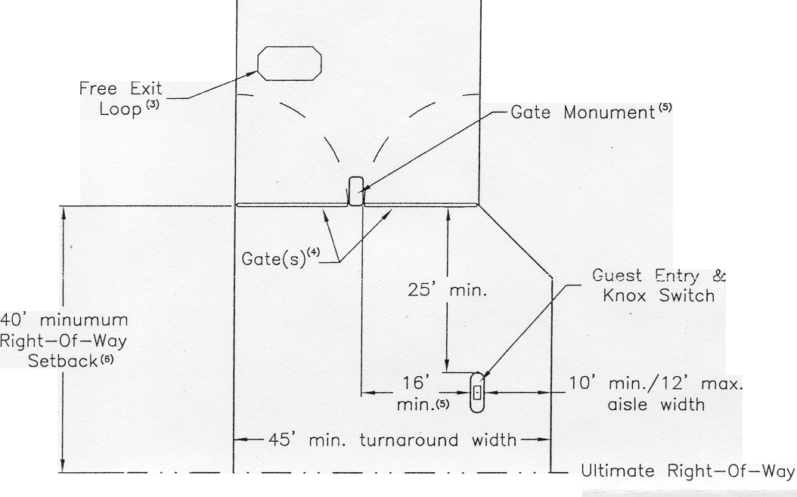
P U B L I C O R P R I V A T E S T R E E T

NOTES:

- The dimensional criteria shown on this layout meet the requirements of the Sacramento County Sheriff, the Sacramento County Department of Transportation and the Fire Districts of Sacramento County. Additional requirements are included in the County's Uniform Fire Code. Alternate designs that adhere to the Code and the criteria above may be approved pending review by the above agencies.
- A Free Exit Loop may be approved in lieu of an approved radio-activated exit device.
- A 36-inch wide pedestrian gate shall be provided within 10-feet of the vehicle gate.
- The gate layout shall consist of one 20-foot min. opening or two separate 16-foot min. openings.
- An optional gate monument may be approved. However, depend- ing on the design a wider turnaround area may be required. If the monument protrudes in front of the gates, the right-of-way setback SCALE: NTS DRAWN BY: KP shall be measured from the monument instead of the gates. DATE: 5/2002 CHECKED BY: KRH

Entry Gate Layout for Existing Developments (Retrofit)
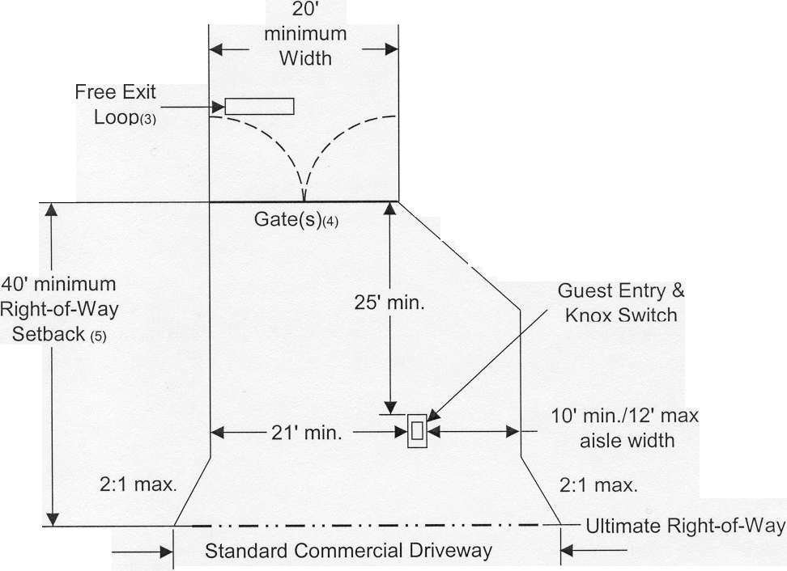

P U B L I C O R P R I V A T E S T R E E T
P u b l i c S t r e e t

Notes:

- The dimensional criteria shown on this layout meet the requirements of the Sacramento County Sheriff, the Sacramento County Department of Transportation and the Fire Districts of Sacramento County. Additional requirements are included in the County's Uniform Fire Code. Alternate designs that adhere to the Code and the criteria above may be approved pending review by the above agencies.
- A 36-inch wide pedestrian gate shall be provided within 10-feet of the vehicle gate.
- A Free Exit Loop may be approved in lieu of an approved radio-activated exit device.
- The gate layout shall consist of one 20-foot min. opening or two separate 16-foot min. openings.
- The actual gate setback requirement will be based on a queuing SCALE: NTS DRAWN BY: PK analysis performed by the Department of Transportation. DATE: 5/2002 CHECKED BY: KRH

